
MANAV RACHNA UNIVERSITY, FARIDABAD
Department of Computer Science and Technology

Course: B.Tech (CST)
Subject: Programming for Problem Solving using Python(CSW208B) Session: 2020-21

Lab 1: Understanding Jupyter IDE for creating and executing a Python program

Learning Outcome CO1: Student will be able to get the Python environment up and running and the basics of Python programming language .
- Writing a program to print a welcome message.

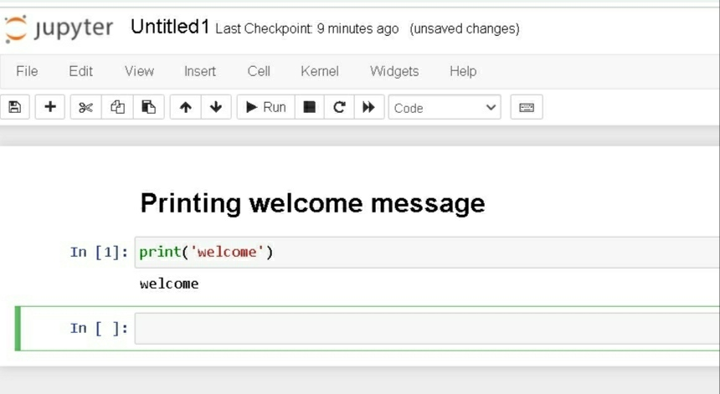

- Write a program to add two numbers.

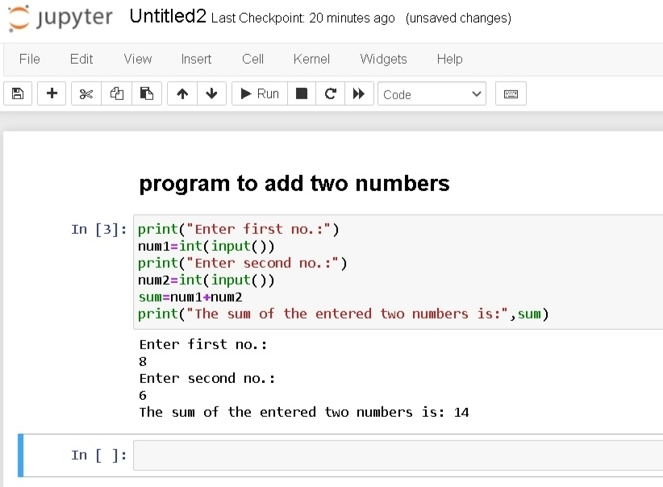

- Write a program to take first name, middle name and last name from the user. Greet the user.

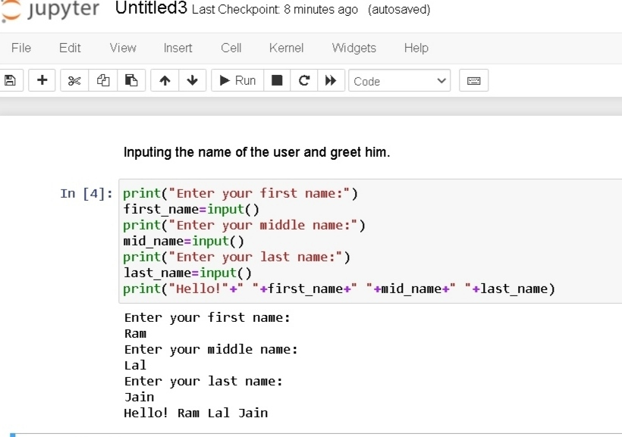


MANAV RACHNA UNIVERSITY, FARIDABAD
Department of Computer Science & Technology

Course: B.Tech(CSE) Semester:IV Subject: Programming for Problem Solving using Python(CSW208B) Session: 2020-21

Lab -2: Programming constructs in python -hands-on practice

Learning Outcome : Student will be able to understand the basics of Python programming language
Blooms Taxonomy Level: BT2, BT3

- Check whether a number is even or odd.

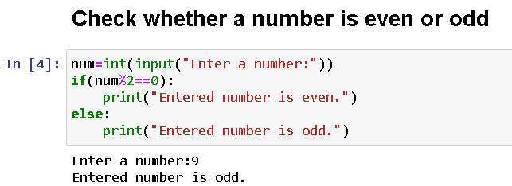

- Check whether an entered year is leap year or not.

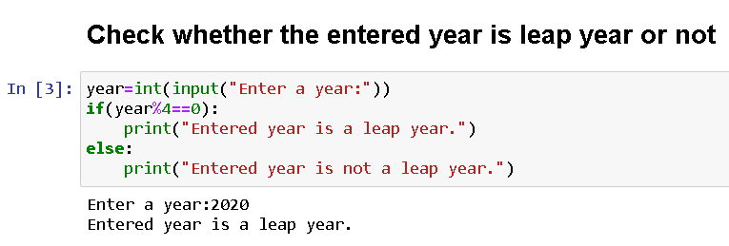

- Write a program to check whether a character is vowel or consonants.

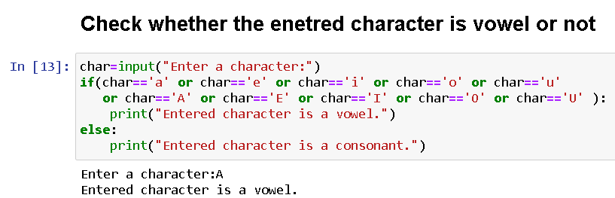

- Write a program to find the smallest of two numbers.

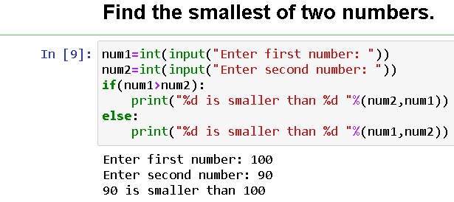

- Find the Factorial of a Number.

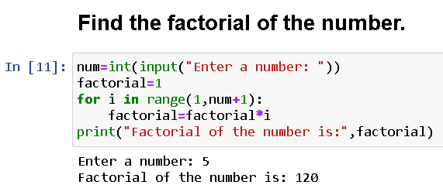

- Write a program to print this patterns
*
* *
* * *
* * * *

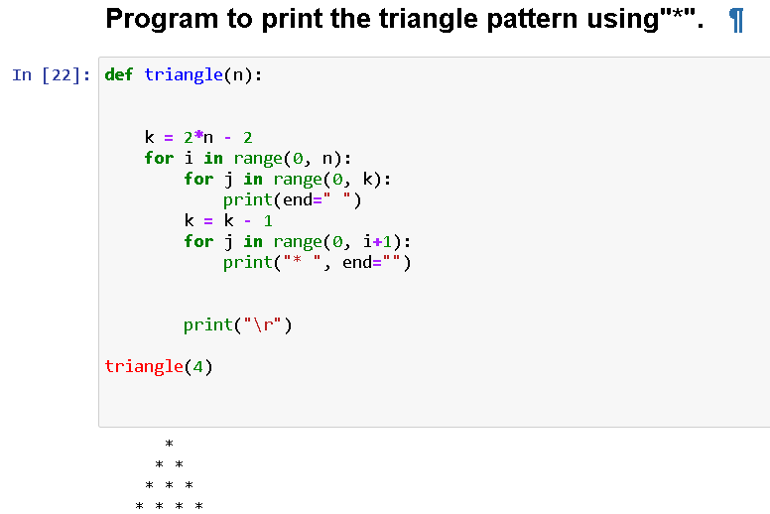

- Write a program to print this series
1 1 2 3 5 8 13

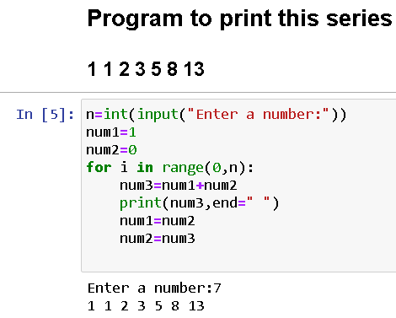

- Check whether a number is prime or not.

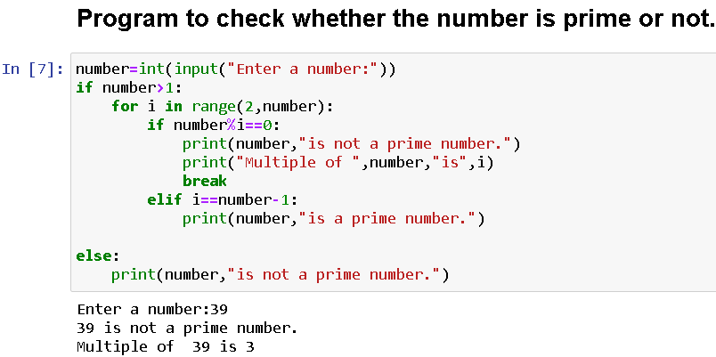

- Make a Simple Calculator.

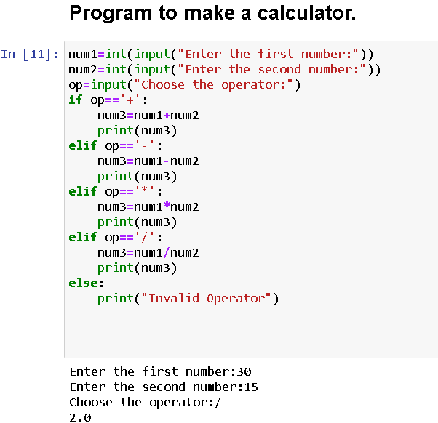

MANAV RACHNA UNIVERSITY, FARIDABAD
Department of Computer & Technology

Course: B.Tech(CSE) Semester:IV Subject: Programming for Problem Solving using Python(CSW208B) Session: 2020-21

Lab-3: Strings and list- hands-on practice

Learning Outcome: Student will be able to implement String Operations.
Blooms Taxonomy Level: BT1, BT2, BT3

- WAP to demonstrate while loop with else statement.

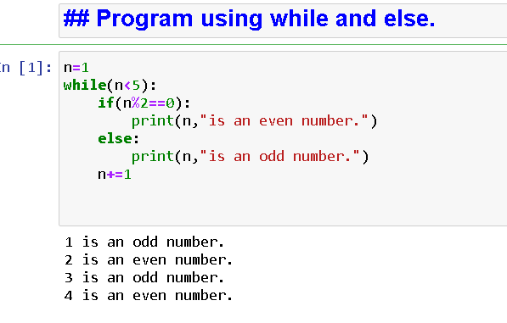
- Print 1st 5 even numbers (use break statement).

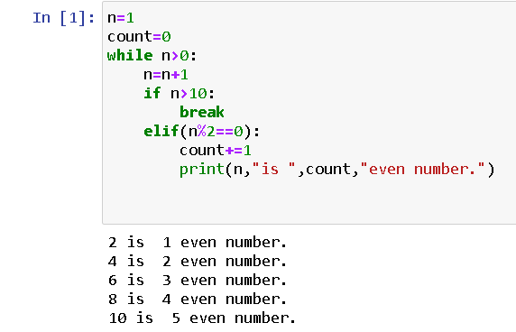

- Print 1st 4 even numbers (use continue statement).

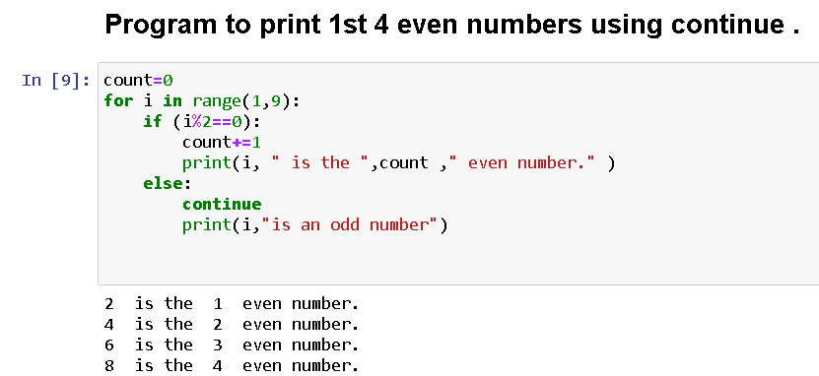
- WAP to demonstrate Pass statements.

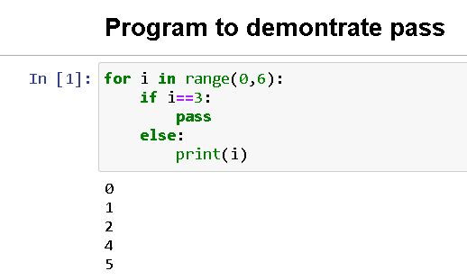

- Write a Python program to calculate the length of a string.

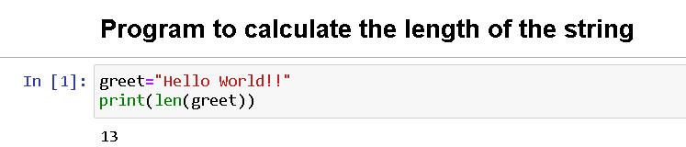

- Write a Python program to count the number of characters (character frequency) in a string.
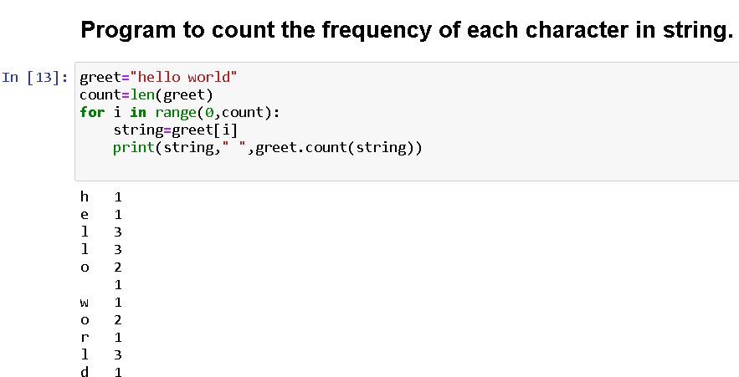

- Write a Python program to get a string made of the first 2 and the last 2 chars from a given a string. If the string length is less than 2, return instead of the empty string.
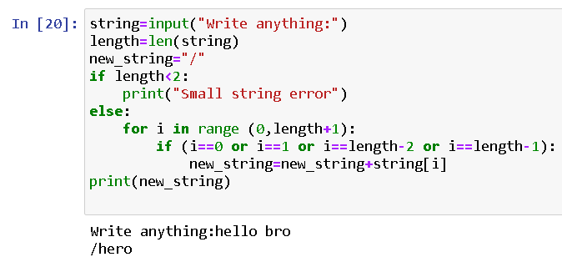
- Write a Python program to get a string from a given string where all occurrences of its first char have been changed to '$', except the first char itself.

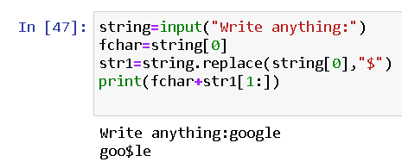

- Write a Python program to get a single string from two given strings, separated by a space and swap the first two characters of each string.

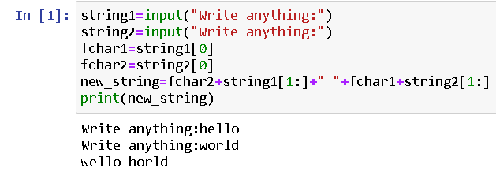

- Write a Python program to add 'ing' at the end of a given string (length should be at least 3). If the given string already ends with 'ing' then add 'ly' instead. If the string length of the given string is less than 3, leave it unchanged.

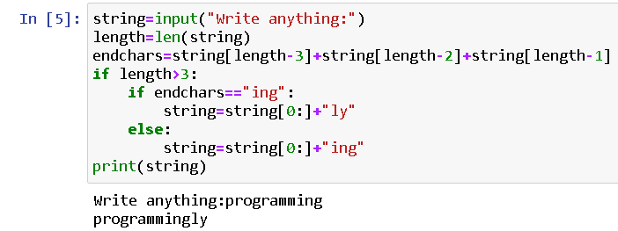


MANAV RACHNA UNIVERSITY, FARIDABAD
Department of Computer Science and Technology

Course: B.Tech(CST) Semester:IV Subject: Programming for Problem Solving using Python(CSW208B) Session: 2020-21

Lab 4-5: Operation on Tuples and List: hands-on practice

Learning Outcome: Student will be able to implement Tuple and List:
Blooms Taxonomy Level: BT1, BT2,BT3
Tuple(LAB-4)
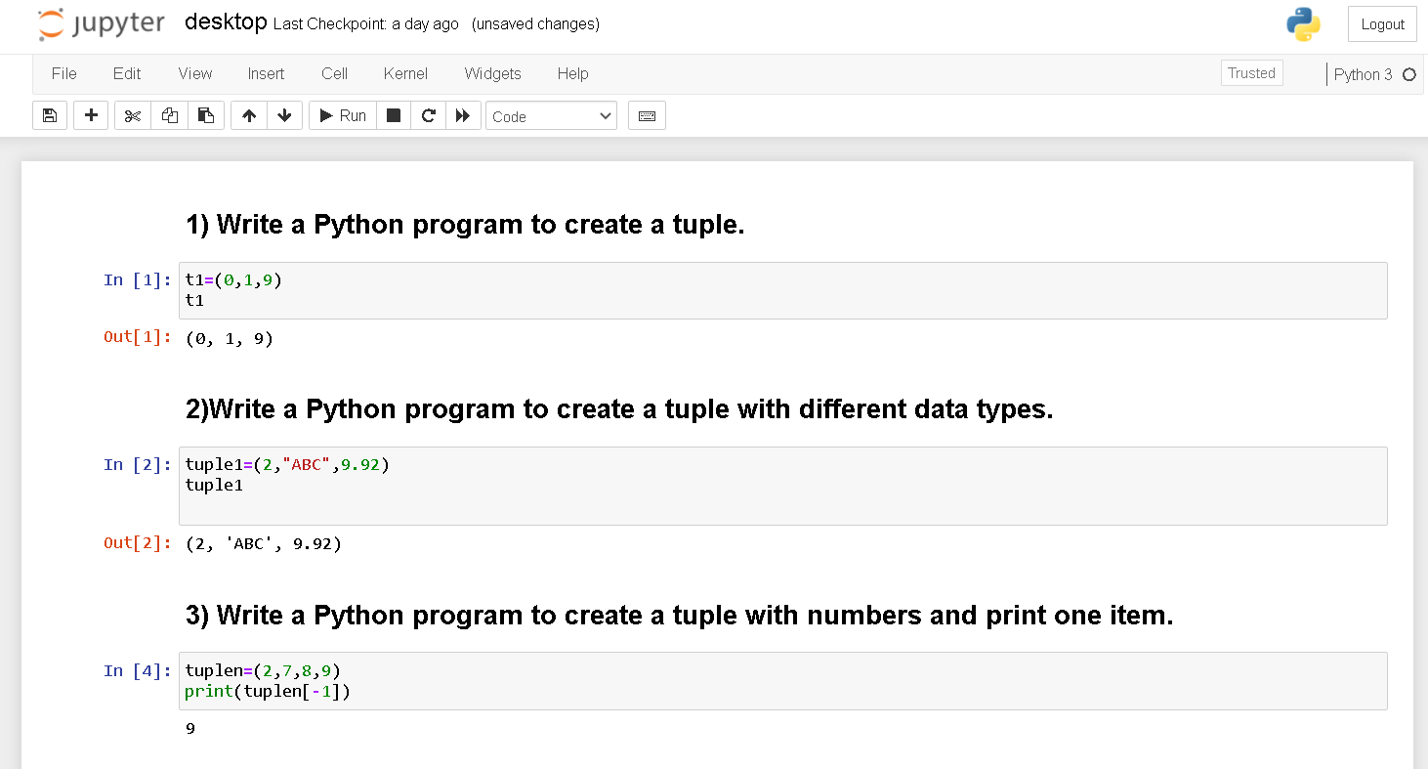

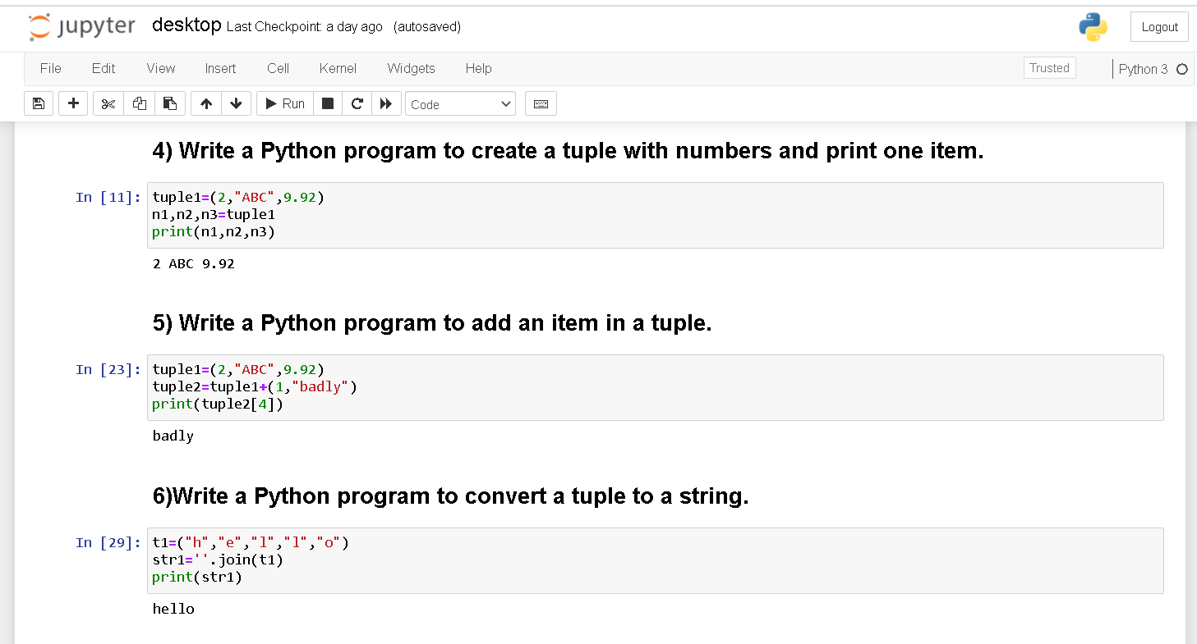

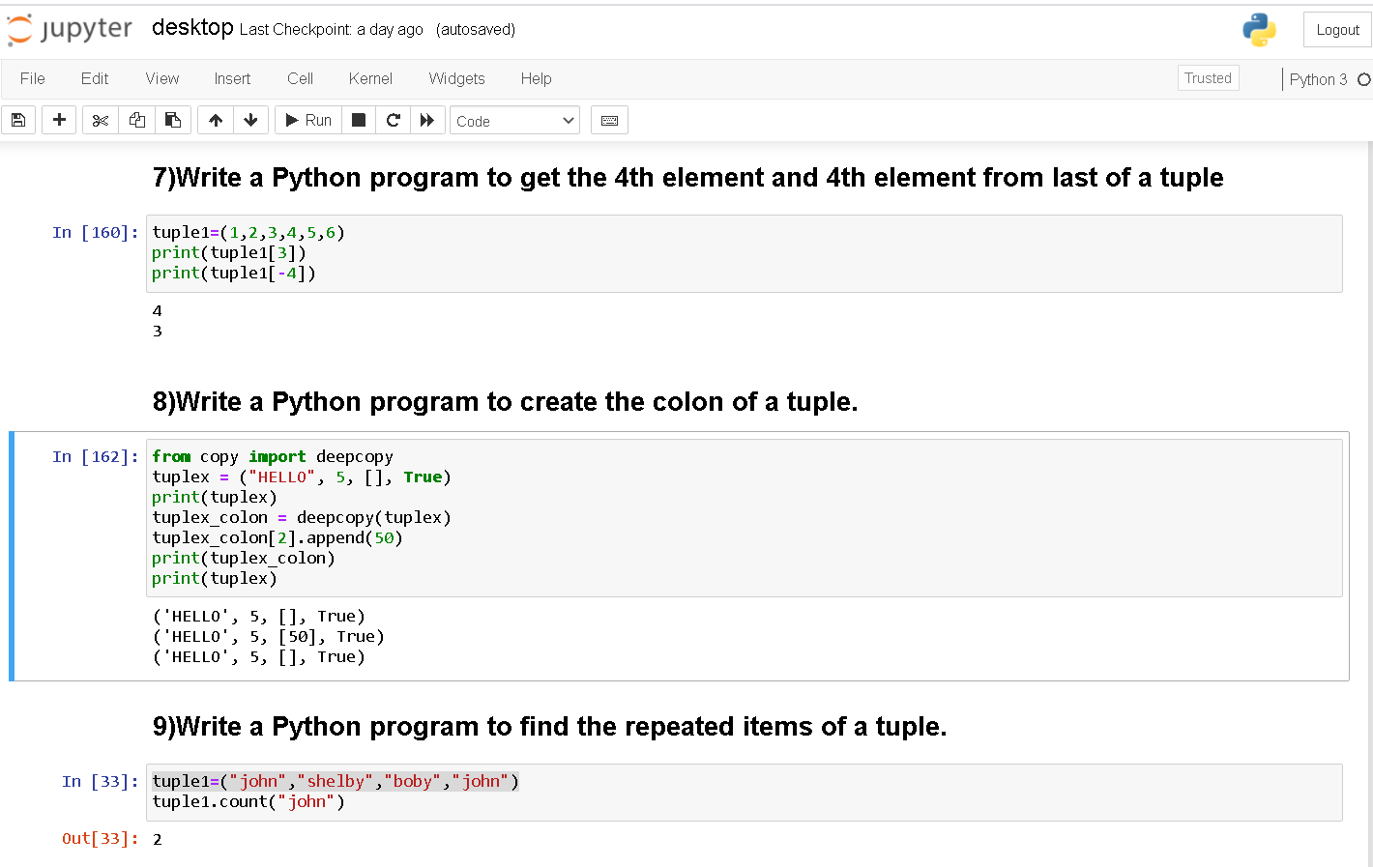

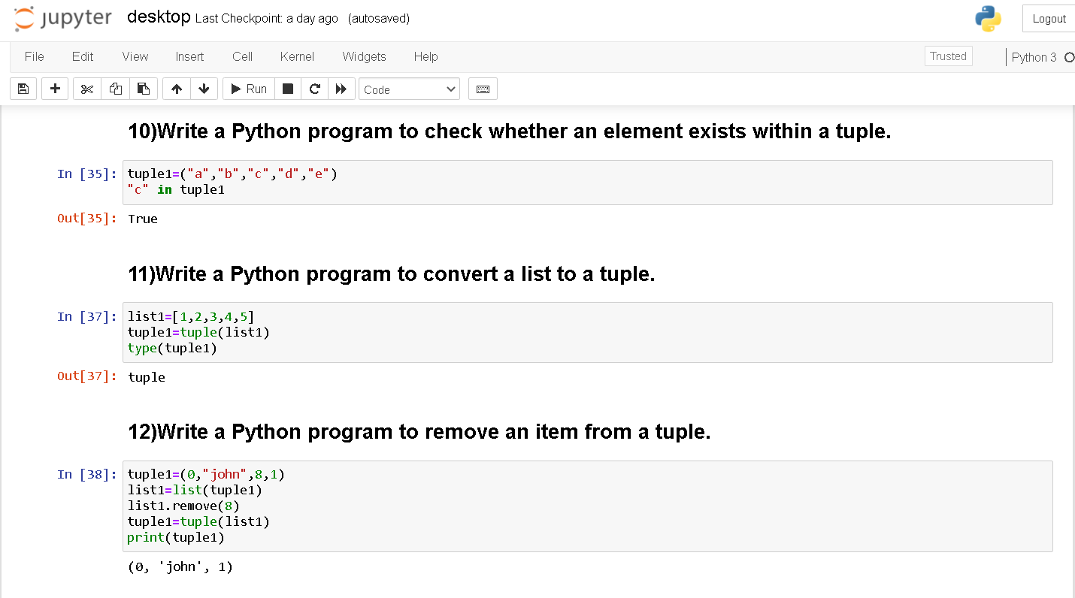

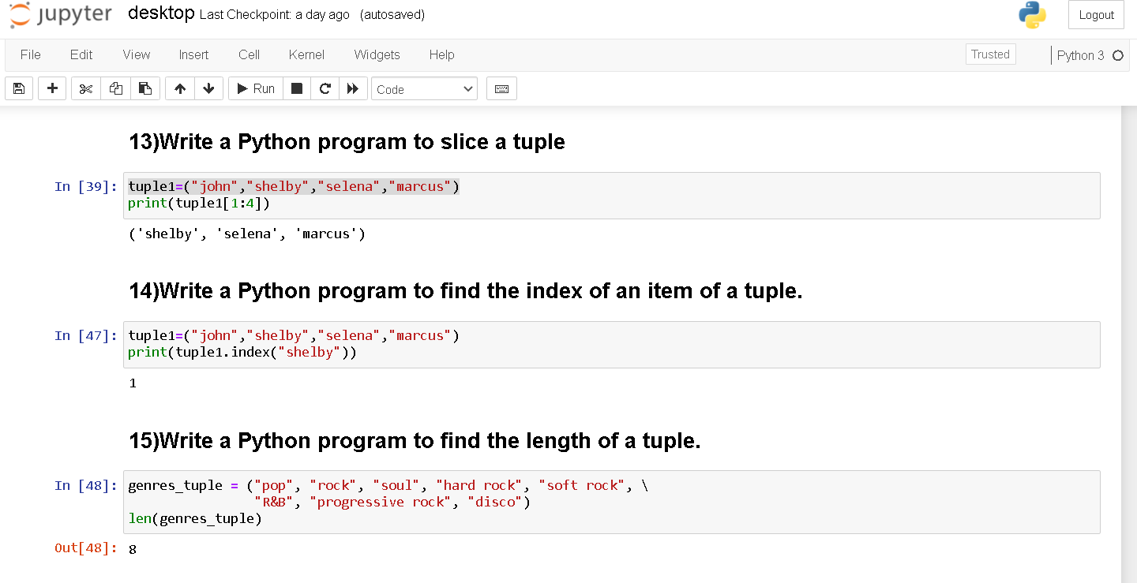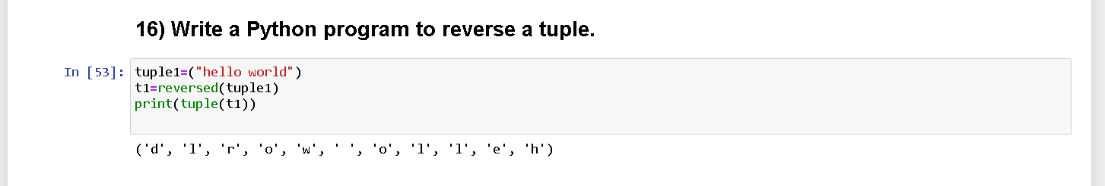
List (LAB-5)
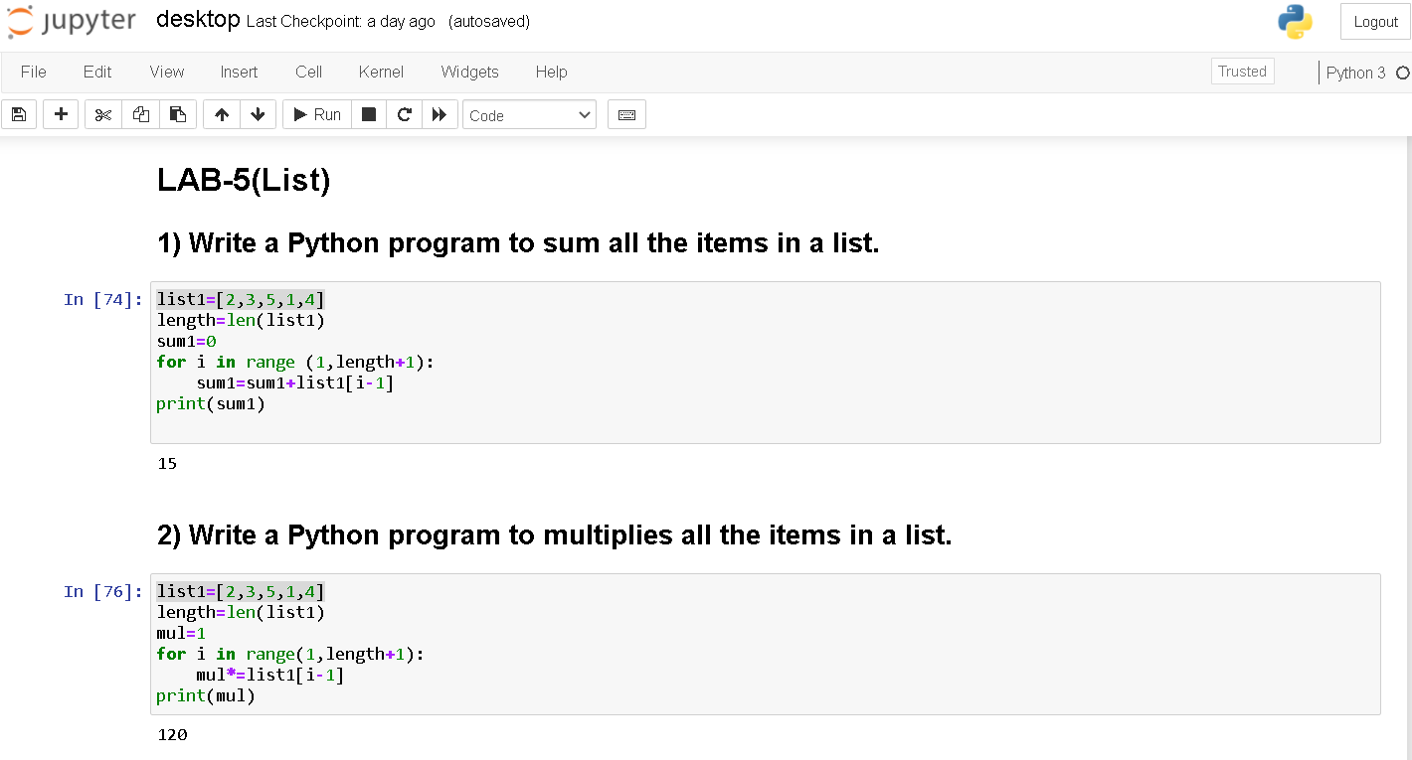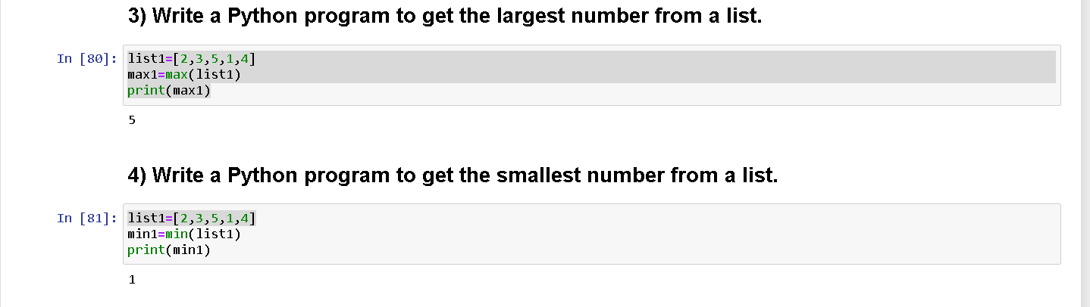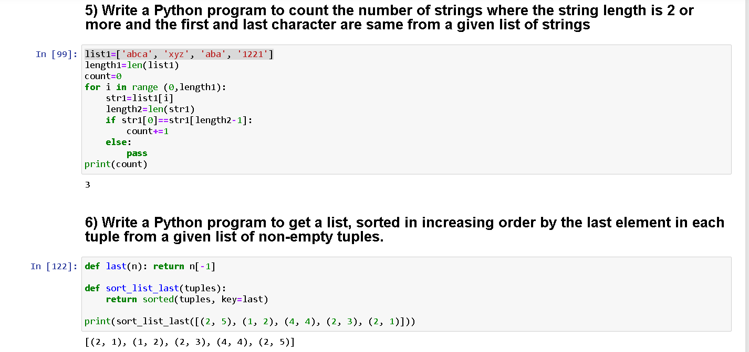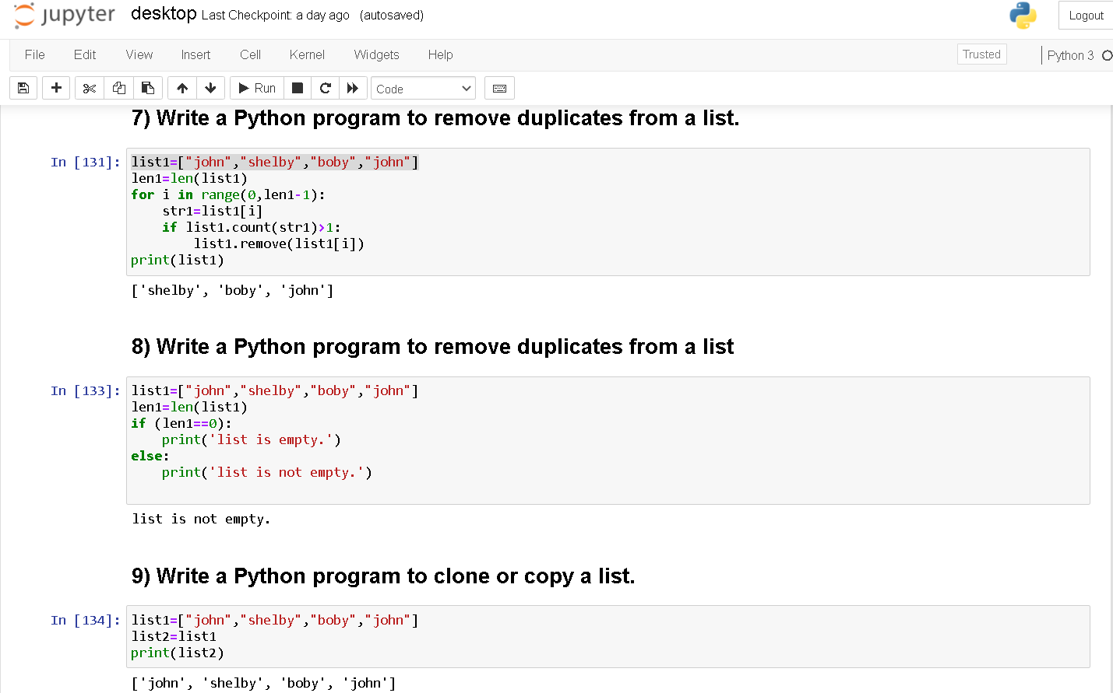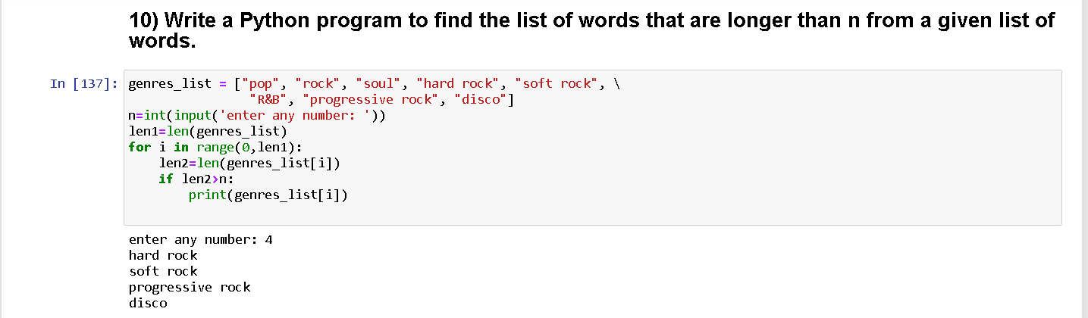

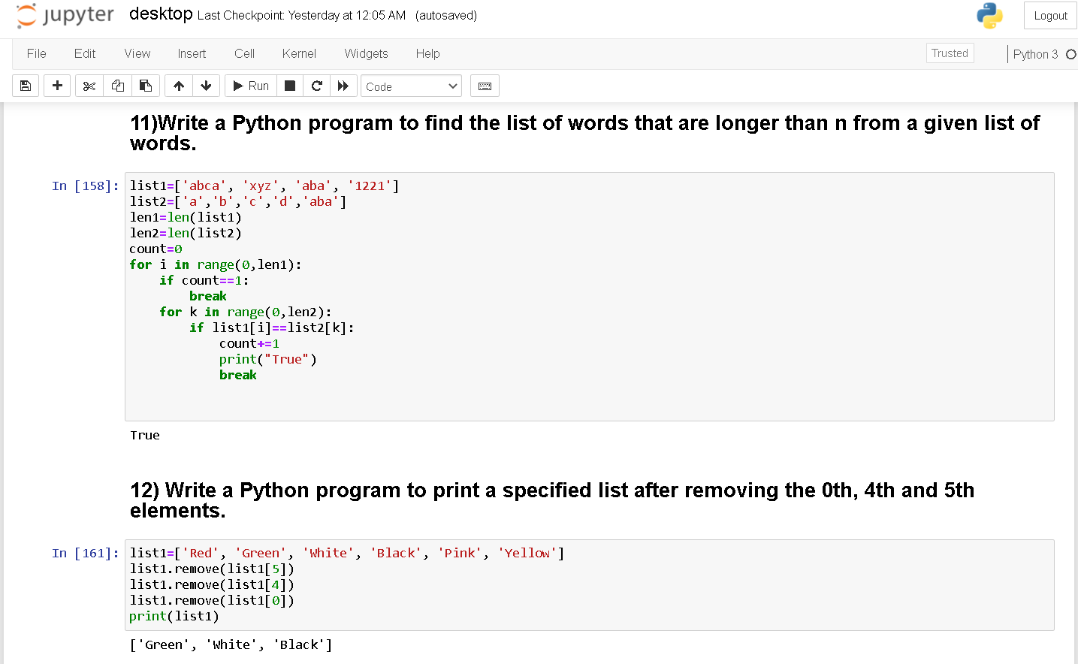

MANAV RACHNA UNIVERSITY, FARIDABAD
Department of Computer Science and Technology

Course: B.Tech(CSE) Semester:IV Subject: Programming for Problem Solving using Python(CSW208B) Session: 2019-20
Lab 6: Operation on dictionary and sets : hands-on practice

Learning Outcome CO1: Student will be able to implement concepts of Dictionary & Sets in Python
Blooms Taxonomy Level: BT1, BT2, BT3
Dictionary
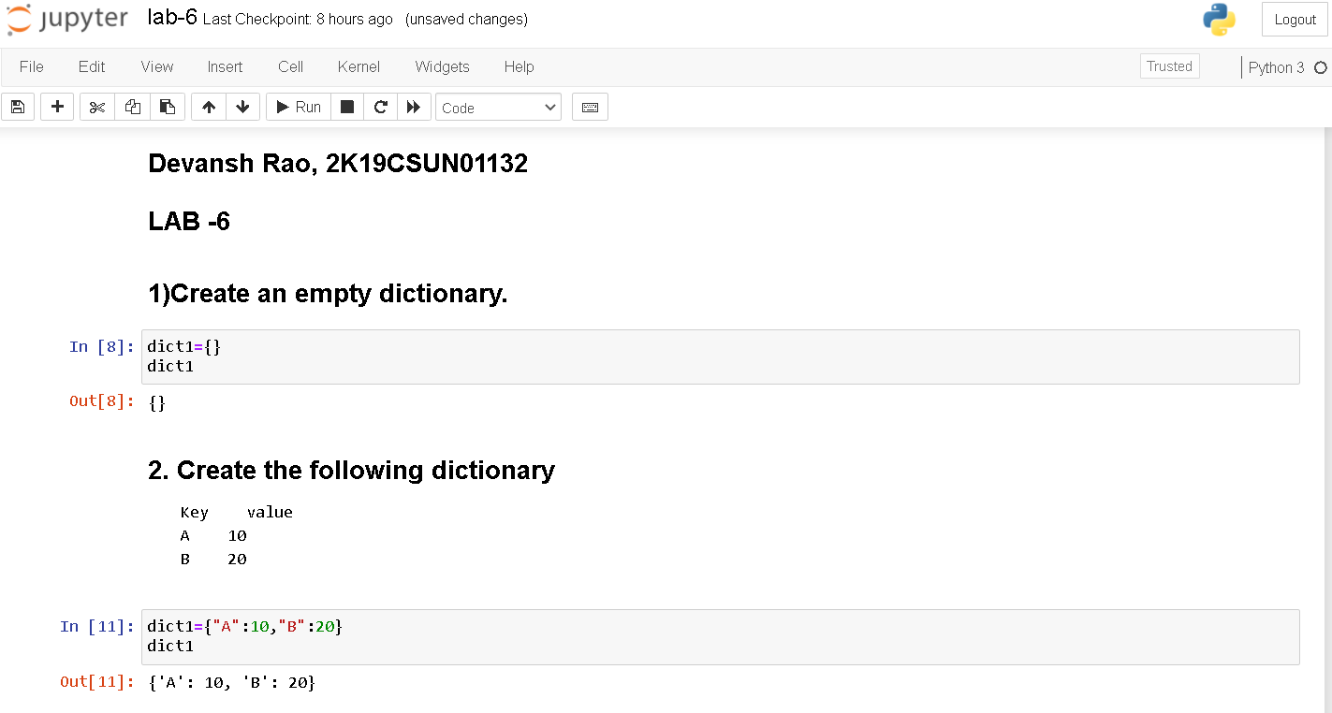

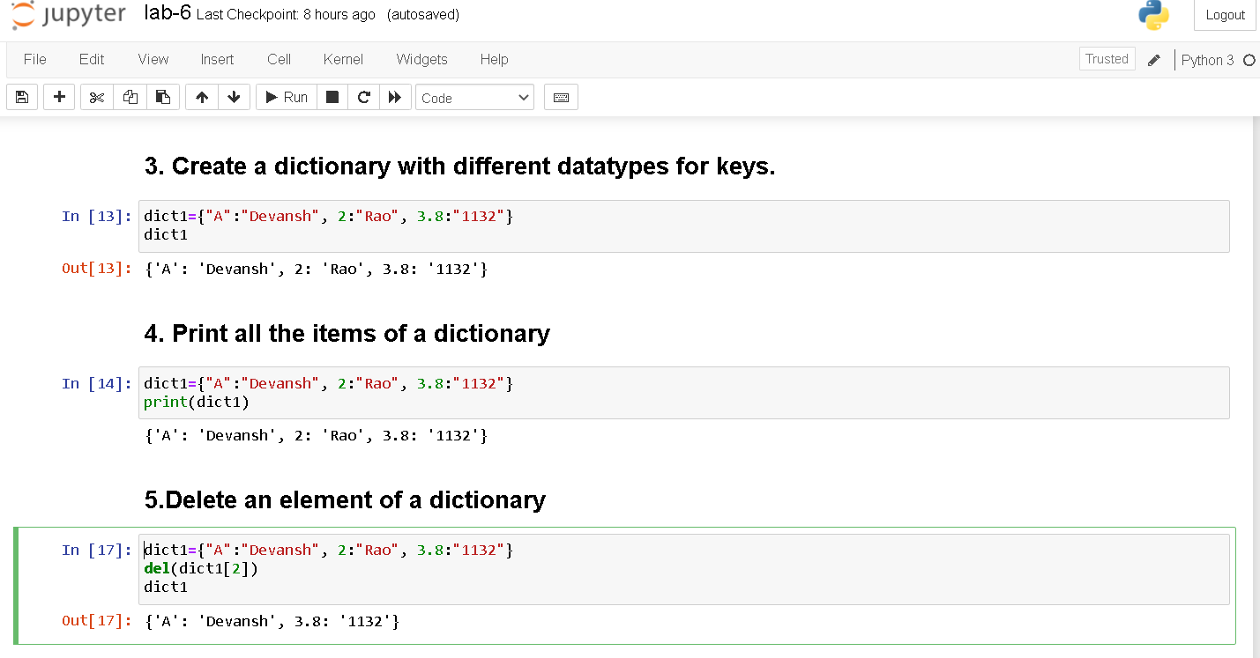

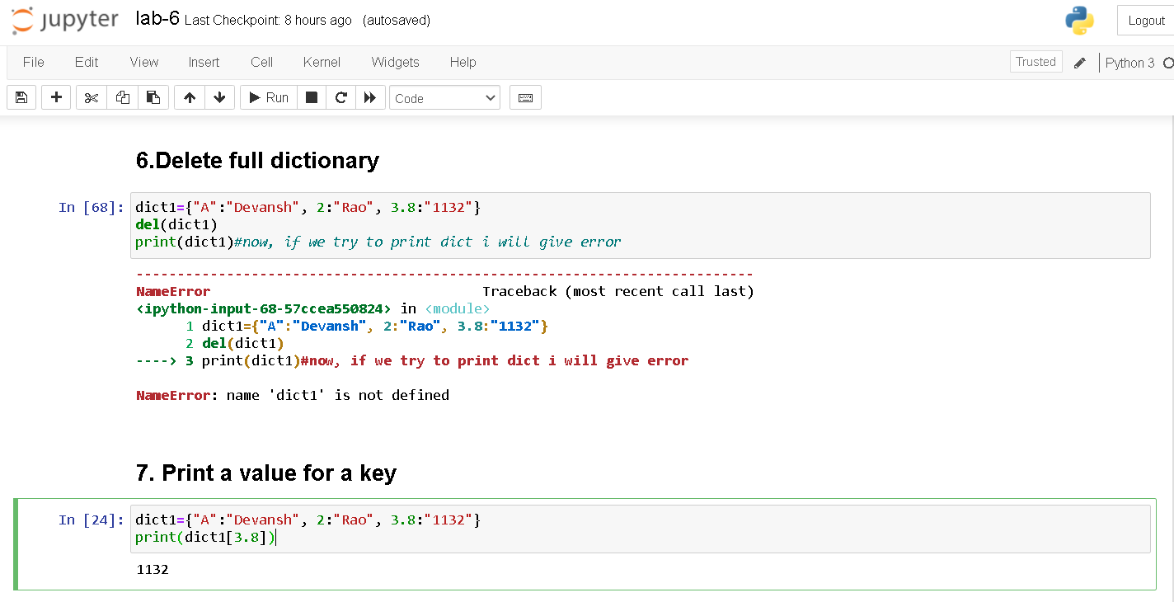
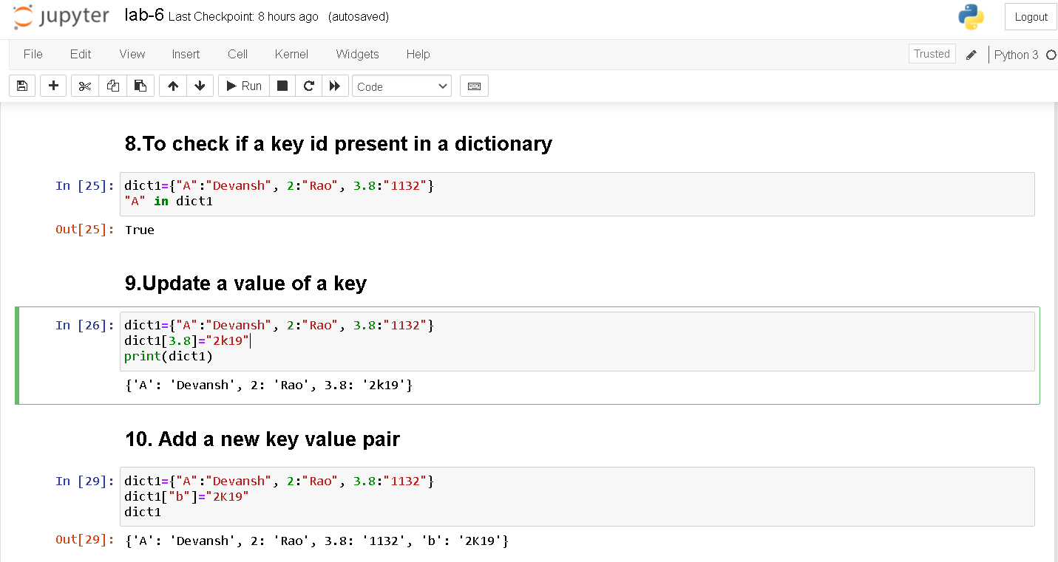

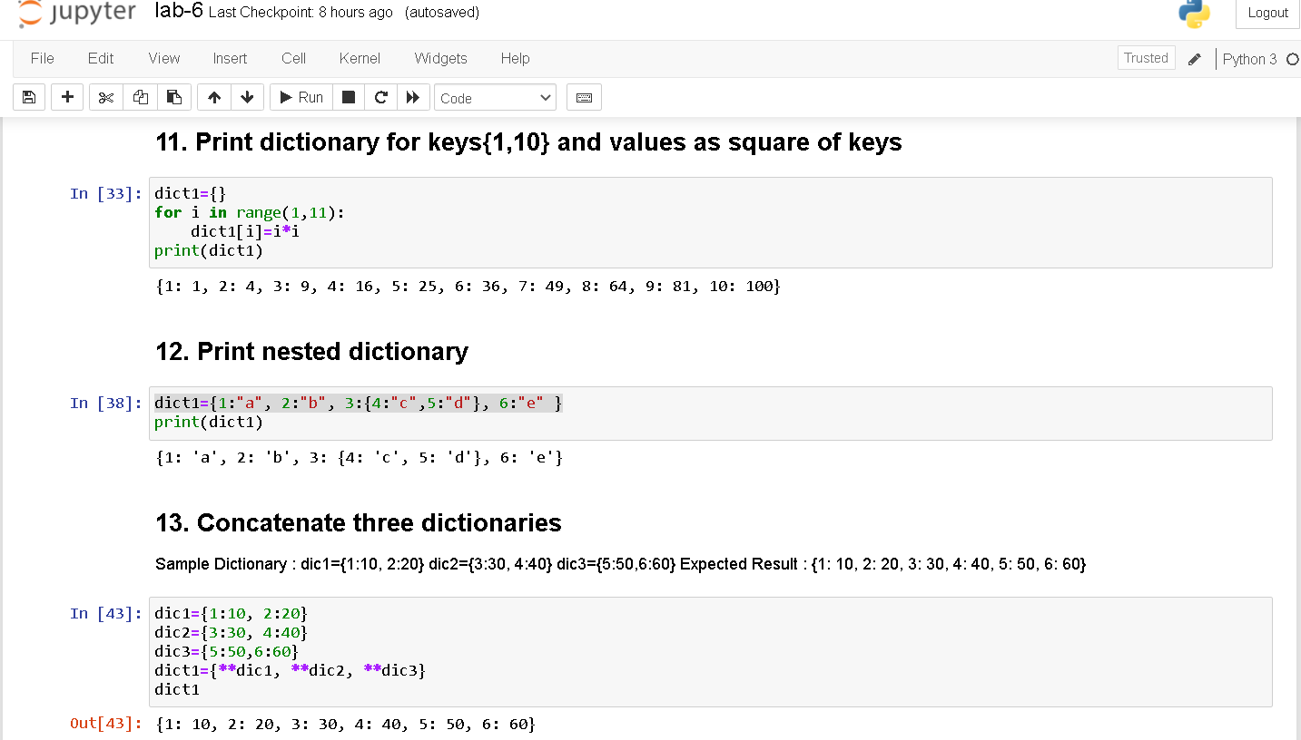

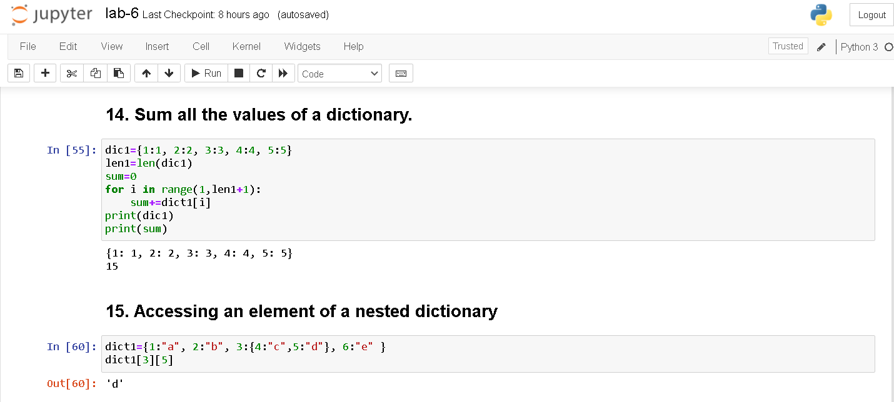

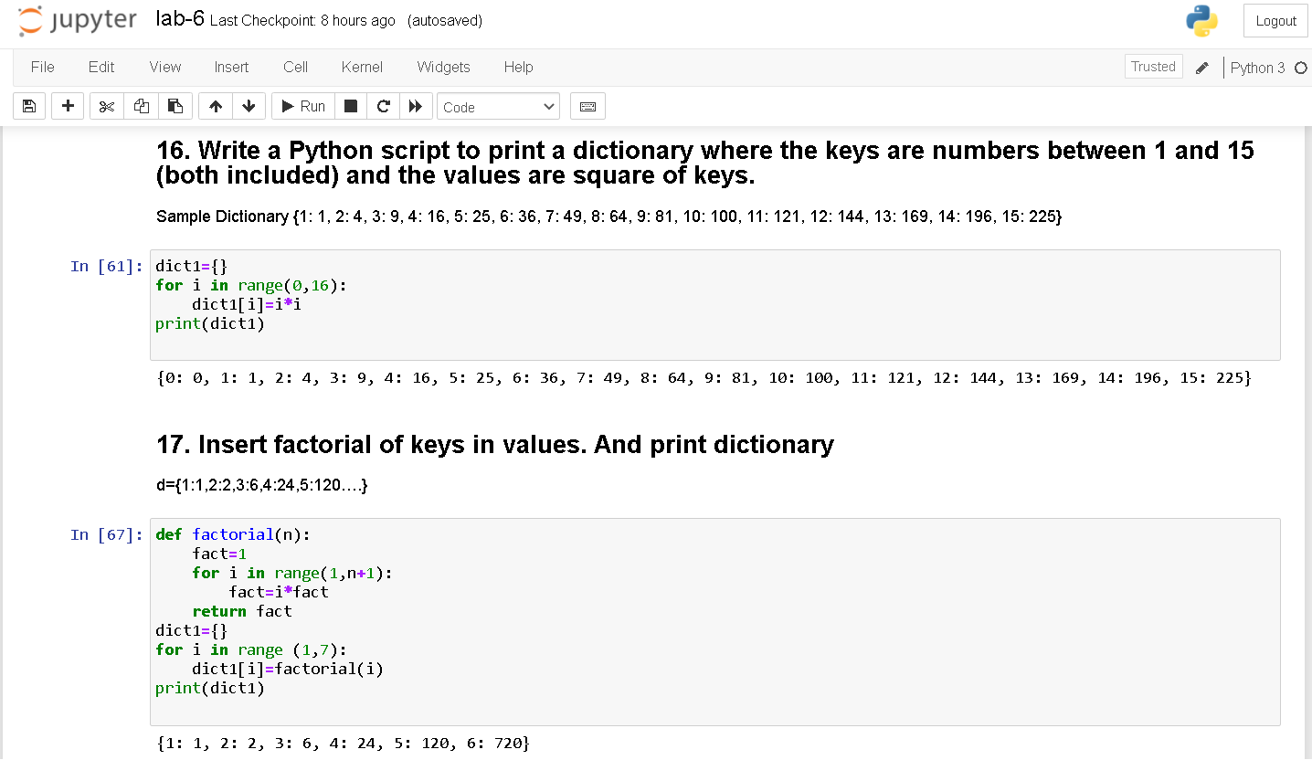

Sets
